
Rosalind Franklin University of Medicine and Science
College of Pharmacy

P1 IPPE COMMUNITY
ACTIVITY WORKBOOK
2025 - 2026

Name: ______________________________________________________

Practice Site: ________________________________________________

Preceptor Name: _____________________________________________

P1 IPPE COMMUNITY SCHEDULE



Rosalind Franklin University – College of Pharmacy 2025-2026
P1 Introductory Pharmacy Practice Experience (IPPE)

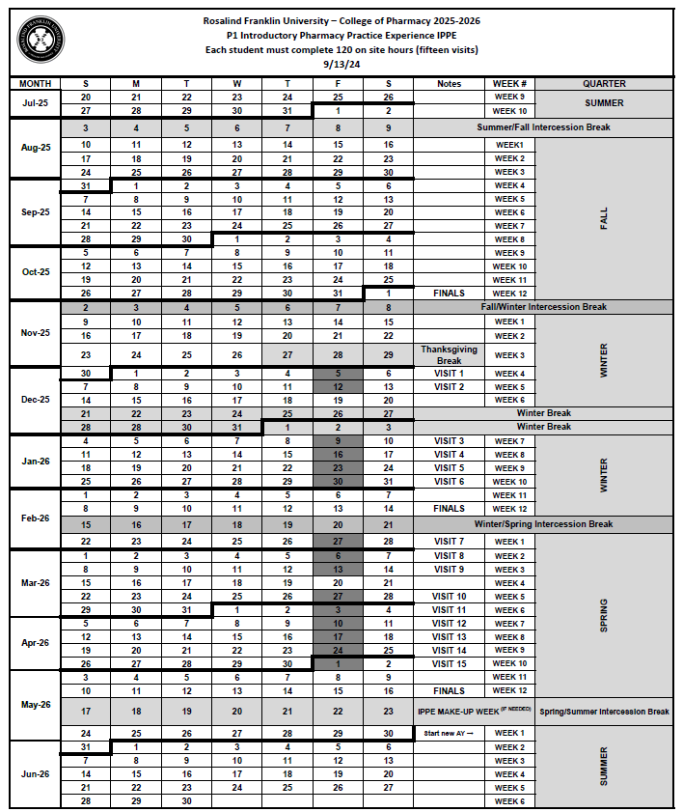
TABLE OF CONTENTS

TABLE OF CONTENTS
WORKBOOK
P1 IPPE Community Schedule | 1
Table of Contents | 2
Academic Integrity Acknowledgement | 4
Office of Experiential Education Contacts | 6
Activity Workbook Instructions | 8
Daily Patient Care Log | 10
Visits #1-2 Preparation & Onsite Orientation | 12
Daily Drug Information Log (3 Per Visit-NON-Rx or one RX) | 19
Visits #3-4 Immunizations | 25
Visit #5 Controlled Substances, Prescription Insurance | 26
Visit #6 Medication Errors | 28
Visit #7 Patient Counseling, Drug Shortages | 29
Visit #8 Midpoint Evaluation | 31
Visit #9 Legal and Regulatory Issues  Practice Manager Oversight | 32
Visit #10 Medication Management Therapy  Pharmacists’ Patient Care Process & Core Entrustable Professional  Activities | 35
Visit #11 Identifying Medication-Related Problems | 40
Visit #12 Nonprescription –Walk Down the OTC Aisle | 41
Visit #13 Walk Down the OTC Aisle (cont.), Medication Guides | 45
Visit #14 Interprofessional Collaboration  Scheduling, Conflict Management | 48
Visit #15 Board Inspection, Final Evaluation | 50

References:
- Accreditation Council for Pharmacy Education, 2016 Standards & Guidelines
- Center for the Advancement of Pharmacy Education’s Educational Outcomes 2013.

Acknowledgements:

- The following manual was adapted with permissions from Beverly Talluto, Texas A&M Health Science Center Irma Lerma Rangel College of Pharmacy Community IPPE Activities Workbook. May she rest in peace. Also from Dawn Carlson from the University of Minnesota Health-System IPPE Workbook, and adapted from the Pharmacist’s Letter.

- Rosalind Franklin University of Medicine & Sciences College of Pharmacy:

  - Ali Salem, P4 pharmacy student for his tireless work in mapping the CAPE outcomes and updating this document for compliance with 2016 ACPE Standards & Guidelines.

  - Dr. Lauren Angelo, Assistant Dean for Academic Affairs her work in developing this workbook.

ACADEMIC INTEGRITY ACKNOWLEDGEMENT

Professionalism
Academic Integrity Acknowledgement

The intent of the IPPE workbook is for each student to get the most out of their IPPE rotation by doing the activities assigned with their preceptors. Students will complete individual assignments independently with the help of their preceptor(s). Students may complete team assignments with other students at the site. The completion of this workbook should accurately reflect the student's experiences at their IPPE site.

Students must document honestly and independently. Copying another student's workbook in any way or form or falsifying information within the workbook is a violation of the University's Standards of Student Conduct and is subject to disciplinary actions.

According to the Rosalind Franklin University of Medicine and Science Student Handbook Standards of Student Conduct, academic integrity forms the cornerstone for building a professional academic community, where individuals come to teach, learn and discover new knowledge. Academic integrity encompasses ethical standards, profession specific standards, and shared Rosalind Franklin University standards.

Academic dishonesty violates the University‘s standards. As an academic community, we will not tolerate any form of academic dishonesty. It is incumbent upon every member of the community to uphold the highest levels of academic integrity.

Academic integrity violations include:
- Cheating
- Fabrication
- Plagiarism
- Redundant Submissions
- Facilitating Violations of Academic Integrity
- Unauthorized Possession or Disposition of Academic Materials
- Unauthorized Examination Behavior
- Any other behavior that is deemed to violate the Professionalism Policy in the Experiential Manual.

Use the following tips to avoid academic integrity violations:
- Students must complete INDIVIDUAL assignments independently.
- If your preceptor does not work with you on assigned tasks or states that a task cannot be completed in the pharmacy, speak to the course director.
- Fill out each portion thoughtfully and completely and assure that every item that you complete is accurate.

By virtue of being enrolled in this course, you are acknowledging the terms above.

OFFICE OF EXPERIENTIAL EDUCATION CONTACTS

Office of Clinical Education Contacts
3333 Green Bay Road
North Chicago, Il 60064-3095
847-578-8782 phone
847-775-6586 fax
copexperientialed@rosalindfranklin.edu


Paul Fina, PharmD, BCACP, BCPS, CSSGB 847-578-3433
Assistant Dean of Clinical Education
paul.fina@rosalindfranklin.edu


Katie Cunningham, PharmD, BCPS 847-578-7682
Director of Clinical Education
kathleen.cunningham@rosalindfranklin.edu

Lisa Michener, PharmD, MS 847-578-8762

Director of Clinical Development
lisa.michener@rosalindfranklin.edu


Eden Diez 847-578-7713
Scheduling and Systems Coordinator
eden.diez@rosalindfranklin.edu

ACTIVITY WORKBOOK INSTRUCTIONS

ACTIVITY WORKBOOK INSTRUCTIONS

Purpose:
The purpose of the Community Introductory Pharmacy Practice Experience (IPPE) is to introduce students to the fundamentals of pharmacy practice in the Community Pharmacy setting. Students should be well on their way to becoming APPE–READY and TEAM–READY by the conclusion of this course.
The workbook intends to guide and augment this learning experience.

Workbook Activities Timeline Instructions:
- Students are required to adhere to complete activities throughout each quarter.
- Students are to work INDIVIDUALLY on the workbook activities:
- Where possible, the activities are sequenced according to what the student is learning in the classroom and pharmacy practice skills course.
Student and Preceptor Responsibilities:
- Preceptors are asked to review exercises with students throughout as assigned and at least once per quarter.
- All workbook activities must be completed neatly with correct grammar for the preceptor to review.

- At the end of EACH site visit the student is expected to update the prescription medication tables, patient activity care log, review his/her timeline, ensure that activities are being completed, and log hours in CORE-ELMS.
- Students must not wait until the last site visit to complete activities. This is disruptive to the preceptor’s workflow and is unprofessional.
- The entire IPPE P1 Community Activities Workbook is required to be completed by the last site visit (Site Visit #15)
All students must attend the required number of 15 site visits even if the workbook is completed before this date.

DAILY PATIENT CARE LOG

Patient-Centered Care
DAILY PATIENT ACTIVITY CARE LOG
Use the following form to record the patient care encounters and activities that took place during each site visit using the table below.
Visit | Date | #Rx Patient Counseling  (note medication(s)/device(s) discussed) | #NonRx Patient Counseling  (note medication(s)/device(s) discussed) | #Immunizations given  (note vaccine(s) given) | #Drug Information Requests
2
3
4
5
6
7
8
9
10
11
12
13
14
15

VISITS #1-2 PREPARATION AND ONSITE ORIENTATION

Professionalism/Communication
ACTIVITY: Visit #1 Preparation

All students must contact their preceptors, by phone, at least 2 weeks BEFORE their first IPPE start date.

Please note this contact is your first chance to make a good impression on your preceptor. Follow these steps to start your experience in a professional manner:

- CHECK CORE-ELMS SITE/PRECEPTOR PROFILE
- Students should refer to the CORE-ELMS Site Profile to read the site description and review all required documents to bring to the first site visit.

- CALL SITE
- At least TWO weeks before to going to your site, call your preceptor to discuss the rotation using the checklist below:

- Determine the first date of the rotation and whether your preceptor is scheduled to work
- Ask for relevant names of staff members that might be on site the first day (e.g., pharmacists, and technicians)
- Determine the time you are expected to arrive
- Confirm the location where you should arrive (e.g., address, office / department)
- Clarify any traffic concerns (confirm directions to location, any constriction, tolls, or detours)
- Ask if parking is available and, if so, where you should attempt to park
- Ask if there are special dress requirements and if lab coat and nametag are appropriate
- Determine any information that should be read or reviewed prior to beginning the experience
- Request any requirements including documents that must to be completed prior to starting the experience
- Verify any documents that need to be provided to the site on the first day
- Communicate that you will provide an ORIGINAL HARDCOPY of your IL Pharmacy Student Technician License.
- Exchange contact information. Provide your contact information (e.g., cell phone and email) and identify the best way to contact the preceptor (e.g., phone number, cell phone number, and email)
.
- If you are unable to reach the preceptor with the initial phone call, verify the day and time of the preceptor’s next scheduled shift and call during that time.

- If you cannot reach the preceptor upon contacting the site after a second attempt or if it is determined that the preceptor no longer works at site, is on vacation, or is on leave, promptly notify the Experiential Office. copexperientialed@rosalindfranklin.edu

- The Experiential Office must be notified no later than 10 days prior to the rotation start date if the student is unable to reach the preceptor so that arrangements can be made to secure another site.

Professionalism/Communication
ACTIVITY: Visits #1-2 Orientation

ACTIVITY 1: Site Orientation Checklist
Review the following topics (as applicable) with your preceptor. Check each item once complete.

◻ | Introductions | Preceptor  Other pharmacy staff
◻ | Goals and objectives | Syllabus review  Assessment form review  Student portfolio  Pharmacy Skills course activities and schedule  Deadlines (record dates):
  Preceptor Assessment of Student | Midpoint________ FINAL________
  Preceptor Self-Assessment | End of IPPE ________
  Student Self-Assessment | Midpoint________ FINAL________
  Student Assessment of Preceptor | End of IPPE ________
  Student Assessment of Site and Course | End of IPPE ________
◻ | Recurring visit requirements | Workbook activity review  Updates to portfolio  Use of forms for recurring activities  Special activities/projects
◻ | Scheduling  (Confirm ALL of the following): | Hours/schedule, including breaks  Calendar with deadlines  Absence policy  College holidays  Logistics Parking  Personal item storage  Restroom/break area location  Dress code
◻ | Introduction to work area | Review of pharmacy layout and workflow  Computer system(s) and expectations  Phone system(s) and expectations for answering phone (i.e., phone etiquette)  Paper documentation system, if applicable  Storage of medications
◻ | Legal and regulatory issues | Copy of student intern license provided  Patient confidentiality and HIPAA (Health Insurance Portability and Accountability Act)  Requirements mandated by OSHA (Occupational Safety and Health Administration)  Antidiscrimination policy  Patient counseling expectations

Professionalism/Communication
ACTIVITY: Visits #1-2 Orientation

Activity 2: Icebreaker
◻ Ask your preceptor to discuss his or her career path (e.g., pharmacy school, residency considerations, job opportunities, organization involvement) and why pharmacy was the chosen field.

◻ Tell your preceptor why you chose pharmacy and what you hope to do when you graduate.

◻ Review with your preceptor your experience so far in pharmacy.

◻ Identify three specific goals you will achieve during your time in this course. Note these in the space below.

Three goals you hope to accomplish in the P1 Community IPPE

Professional Opportunities in Pharmacy at Site
- Does the site offer summer pharmacy internships for pharmacy students? What is the process for applying?

- Ask your preceptor what they think the best way for a student to increase their chances of getting hired at the site?

- How do pharmacists typically get hired and promoted at the pharmacy (from within, from outside, is prior experience or a community practice residency preferred)?

- Is the site is currently hiring? Describe any pharmacy positions that are currently available.
Professionalism/Communication
ACTIVITY: Visits #1-2 Orientation
Activity 3: Roles and responsibilities
Familiarize yourself with roles and responsibilities.
- Request to review job descriptions for the following roles at your site.
- Describe at least three to five roles and responsibilities of each individual and how they differ?
Individual | Responsibilities
Pharmacist-in-Charge
Staff Pharmacist
Technician
District Manager
Store Manager
Other | Fill in any role that is important at your site
Individual | Responsibilities (What does your site expect of P1 students)
IPPE Student

Medication Use Systems Management
Visits #1-2

Activity 5: Prescription Processing and Transfers
List the items that must be included on a prescription label by law:

For each of the following prescription processing steps, check the boxes to identify the individual(s) who are permitted to be involved with the activity.
Rx Processing Step | Pharmacist | Student Intern | Technician | Note any exceptions
Receives prescription from patient | ◻ | ◻ | ◻
Enters prescription data into computer | ◻ | ◻ | ◻
Addresses drug interaction and dose alerts | ◻ | ◻ | ◻
Submits claim and adjudicates insurance problems | ◻ | ◻ | ◻
Fills the prescription order (e.g., counts, pours, labels) | ◻ | ◻ | ◻
Compounds prescriptions | ◻ | ◻ | ◻
Checks and verifies the prescription order | ◻ | ◻ | ◻
Bags or files the prescription for pick-up | ◻ | ◻ | ◻
Retrieves prescription for patient | ◻ | ◻ | ◻
Counsels patient | ◻ | ◻ | ◻

E-Prescriptions:
1. How does the pharmacy receive and process electronic prescriptions?

2. What are the benefits to e-prescribing?

3. What are the challenges with e-prescribing?
Medication Use Systems Management
Visits #1-2

Activity 5: Prescription Refills:
1. When processing a refill for a patient, is the original prescription reviewed (either hard copy or scanned image)? ◻ Yes ◻ No

2. If a patient is out of refills for a medication, what is the process for getting additional refills or a new prescription?

3. How does the pharmacy handle an emergency supply if the patient is out of refills and the prescriber cannot be contacted?

4. How is patient counseling for refills approached at your site?

Prescription Transfers:
List what needs to be documented when receiving a prescription that is being transferred to your pharmacy.
For OEE Use: Complete Incomplete

Did you participate in a prescription transfer? If so, reflect on what went well, and what you might do differently the next time.
DAILY DRUG INFORMATION LOG

Learner
DAILY ACTIVITY: Nonprescription Drug Information DAILY STUDENT INDIVIDUAL LOG
Complete prescription medication table for two drug classes at each site visit.
- Students should locate two products in the OTC aisle from each of the classes listed.
- Use the Top 300 Drugs list from the Pharmacy Skills Education Lab to narrow the search if necessary.
- Carefully read the product labeling and complete the following table.
Class | Brand /Generic Names | Adult Dose | Child Dose (6 to < 12 years) | Child Dose (2 to <6 years) | List 2 adverse effects, warnings, precautions, or pertinent counseling points
Analgesic
Antacids
Antihistamines
Cough Suppressant or Expectorant

Learner
DAILY ACTIVITY: Nonprescription Drug Information DAILY STUDENT INDIVIDUAL LOG
Complete prescription medication table for two drug classes at each site visit.
- Students should locate two products in the OTC aisle from each of the classes listed.
- Use the Top 300 Drugs list from the Pharmacy Skills Education Lab to narrow the search if necessary.
- Carefully read the product labeling and complete the following table.
Class | Brand /Generic Names | Adult Dose | Child Dose (6 to < 12 years) | Child Dose (2 to <6 years) | List 2 adverse effects, warnings, precautions, or pertinent counseling points
Decongestants
Herbal Supplements & Vitamins
Laxatives
Topical Analgesics or Antipruritics

Learner
DAILY ACTIVITY: Prescription Drug Information DAILY STUDENT INDIVIDUAL LOG
Complete prescription medication table for two drug classes at each site visit.
- Students should identify one prescription filled for each of the drug classes listed.
- Use the Top 300 Drugs list from the Pharmacy Skills Education Lab.
- View the medication labeling and complete the following table.
Class | Brand Name | Active Ingredient(s) | Therapeutic Use | Dosage Forms | List 2 adverse effects, precautions, or pertinent counseling points
ACE Inhibitors
Alpha-agonists

Angiotensin II Receptor Blockers

Antibiotics

Learner
DAILY ACTIVITY: Prescription Drug Information DAILY STUDENT INDIVIDUAL LOG
Complete prescription medication table for two drug classes at each site visit.
- Students should identify one prescriptions being filled for each of the drug classes listed.
- Use the Top 300 Drugs list from the Pharmacy Skills Education Lab.
- View the medication labeling and complete the following table.
Class | Brand Name | Active Ingredient(s) | Therapeutic Use | Dosage Forms | List 2 adverse effects, precautions, or pertinent counseling points
Anticoagulants/
Antiplatelets
Antihyperlipidemics

Beta-Blockers

Calcium Channel Blockers
Diuretics

Learner
DAILY ACTIVITY: Prescription Drug Information DAILY STUDENT INDIVIDUAL LOG
Complete prescription medication table for two drug classes at each site visit.
- Students should identify one prescription being filled for each of the drug classes listed.
- Use the Top 300 Drugs list from the Pharmacy Skills Education Lab.
- View the medication labeling and complete the following table.
Class | Brand Name | Active Ingredient(s) | Therapeutic Use | Dosage Forms | List 2 adverse effects, precautions, or pertinent counseling points
NSAIDs
Opioids
Sedative/Hypnotics
Selective Serotonin Reuptake Inhibitors
Thyroid Replacement Hormones

Patient-Centered Care
Visits #3-4

Activity: Immunizations
1. Does your pharmacy provide immunization services? ◻ Yes ◻ No

2. Which vaccines does your pharmacy provide?

3. What ages of patients are able to be vaccinated at your site?

4. Which of the following models are used to administer vaccines (select all that apply)?
◻ By appointment ◻ Walk-in ◻ Vaccine clinic (off site)

5. Where are the vaccines stored?

6. Who maintains the temperature log?

7. How often is the temperature monitored?

8. Whom does the pharmacy contact if a vaccine is not shipped or stored properly?

9. Where in the pharmacy are vaccines administered to patients?

10. What does the emergency supply kit contain?

11. How does the pharmacy get paid for the immunization service?

12. Who is permitted to administer the vaccines?

13. Where are a patient’s vaccination records stored?

Medication Use Systems Management
Visit #5

Activity 1: Controlled Substances
- What directive/warning must be included on a controlled substance prescription label (on the bottle that is given to the patient) that is not needed on a prescription for a legend drug?

- How does the controlled substance prescription expiration date differ from non-controlled prescriptions?

3. Look at a prescription from a prescriber for a controlled substance. Work with your preceptor to verify that the DEA number is correct.

4. List two ways to identify a forged or fake prescription:
1)

2)

5. How are controlled substances filed, stored and/or separated from other medications in the pharmacy?

6. Please describe your site’s policy for the dispensing of naloxone.

7. Discuss the following with your preceptor and check each item once complete. You do not need to record the answers or responses.
◻ | What would your preceptor do if he or she received a fraudulent prescription from a patient?
◻ | Review with your preceptor the purpose and components of the DEA 222 form.
◻ | Who is permitted to complete this form?
◻ | What if a mistake is made?
◻ | How does the pharmacy dispose of expired CII products?
◻ | Has your preceptor used the Illinois Prescription Monitoring website (www.ilpmp.org)? ◻ Yes ◻ No  If so, what was the reason for using the site?
◻ | How often does your pharmacy take an inventory of CII products?
◻ | How is this inventory documented?
◻ | What steps are taken if the count is not what was expected?
◻ | How often does your pharmacy take an inventory of CIII-V products?
◻ | How is this inventory documented?

Medication Use Systems Management
Visit #5

Activity 2: Prescription Insurance
Discuss the following with your preceptor check each item once complete.
◻ | Describe types of insurance does your pharmacy accept (e.g., Medicare Part B, Part D, Medicaid, TRICARE, private, etc.)?
◻ | Describe fields must be populated to submit an insurance claim?
◻ | Describe steps does your pharmacy take to bill for Workers’ Compensation?
◻ | What does your pharmacy do if a patient is paying with two different insurance plans?
◻ | How does your pharmacy get reimbursed for the claims submitted?
◻ | What are the top 3 reasons your pharmacy receives a rejected claim?
◻ | How does your preceptor explain prior authorization to a patient?
◻ | Has your preceptor ever worked with a patient to enroll him or her in a prescription drug assistance program? ◻ Yes ◻ No  If so, what was the most recent program used?

After completing this exercise, describe three things you learned that you did not know before about prescription insurance?

Medication Use Systems Management
Visit #6

Activity: Medication Errors
1. What is meant by the term “Tall Man Letters?”

2. Does your pharmacy use Tall Man Letters?
◻ Yes ◻ No
If so, list 5 commonly dispensed medications for which are they used:

3. When counseling is provided, is the patient’s prescription product shown to the patient to verify the medication dispensed? ◻ Yes ◻ No

4. Do the pharmacists and technicians receive ongoing information about medication errors occurring within the organization, error-prone situations, errors occurring in other pharmacies, and strategies to prevent such errors? ◻ Yes ◻ No

5. If a medication error occurs, what steps are taken to document the error internally?

6. If a medication error occurs, what external source is used to document the error (e.g., MedWatch, ISMP)?

7. Has anyone in the pharmacy ever reported an error to MedWatch or ISMP?
◻ Yes ◻ No

If so, describe the error and what was reported:

Educator
Visit #7

Activity 1: Patient Counseling
Work with your preceptor to identify a prescription a patient is picking up for which you would feel comfortable counseling the patient. Prior to counseling, discuss the key counseling points and patient education you will need to provide. When the patient picks up the prescription, provide the counseling while being supervised by your preceptor. After the patient has left, complete the following with your preceptor:

Medication dispensed: _________________________________________________________________

CONSULTATION:
Which of the following did the student pharmacist discuss with the patient? Check all that apply.
- Product/ingredient name and intended use
- Directions for use
- Adverse effects
- Drug interactions
- Duration of use
- Special precautions
- Proper storage
- Self-monitoring of effectiveness
- Expectations of treatment/When to contact health care provider
- Nonpharmacologic treatment options

Consultation Assessment (check one):
How well was the medication information communicated to the patient?
□ Inadequate □ Needs Improvement □ Satisfactory □ Excellent

ASSESSMENT OF INTERACTION AND COMMUNICATION SKILLS: Check all that apply.
□ Introduces self
□ Verifies patient and correct prescription
□ Maintained eye contact with the patient
□ Asked open-ended questions when appropriate
□ Clearly communicated information to patient
□ Used terminology appropriate to the patient’s level of understanding
□ All important counseling points and key messages were covered
□ Seemed friendly and empathetic
□ Demonstrated an organized approach
□ Gave patient an opportunity to ask questions
□ Adequately assessed patient understanding

Communication Skills (check one):
□ Not acceptable □ Acceptable □ Outstanding
(Less than 5 checked items) (5-10 checked items) (All 11 items checked)

Feedback for the Student Pharmacist:

Medication Use Systems Management
Visit #7

Activity 2: Drug Shortages
1. Which medication shortages have impacted the pharmacy in recent months (list at least 3)?

- How have medication shortages directly impacted patient care?

3. What has the pharmacy done to accommodate patients needing medications that are not available? For each medication noted above, provide an example of measures taken to assist the patients.

Visit 8: MIDPOINT AND FINAL ACTIVITY WORKBOOK EVALUATION

(MUST BE DISCUSSED AND
DOCUMENTED IN CORE-ELMS)

Professionalism

Visit #9

Activity 1: Legal and Regulatory Issues
1. What routine training is required of employees (e.g., HIPAA, OSHA BBP, Fraud, Waste, and Abuse) at the pharmacy?

2. How is this training accomplished and documented?

3. Does your pharmacy have a CLIA Certificate of Waiver?
◻ Yes ◻ No
If so, who is the Director and what does this waiver permit the pharmacy to do?

4. Discuss the following with your preceptor:

◻ | What are the responsibilities of the Pharmacist-in-Charge (PIC)?
◻ | What are the requirements to maintain licensure as a pharmacist in Illinois?
◻ | What requirements must be met for pharmacy technicians?
◻ | What are the requirements for selling insulin syringes and needles to a patient without a prescription? With a prescription?
◻ | What steps must be taken when selling a product containing pseudoephedrine to a patient without a prescription?
◻ | What does it mean if a prescription has “Brand Medically Necessary” written on it?
◻ | What would the pharmacist do if a prescriber writes a prescription that is not within his or her scope of practice (e.g., a dentist writes a prescription for his daughter for oral contraception)?
◻ | Is the pharmacist permitted to leave the pharmacy if no other pharmacists are working? If so, under what conditions?
◻ | What security requirements must be met if the pharmacy maintains shorter hours than the store in which it resides?

Medication Use Systems Management
Visit #9
Activity 2: Review Practice Manager Oversight

Discuss the following supporting tasks with a pharmacy technician and or pharmacist manager. Ask them specifically to describe their role in and to share any examples of how they oversee or are involved in each of following supporting tasks.

DOMAIN |  | Example Supporting Task | Discussed  Practice
PRACTICE MANAGER DOMAIN | Oversee the pharmacy operations for an assigned work shift. | • Implement pharmacy policies and procedures.
PRACTICE MANAGER DOMAIN | Oversee the pharmacy operations for an assigned work shift. | • Supervise and coordinate the activities of pharmacy technicians and other support staff.
PRACTICE MANAGER DOMAIN | Oversee the pharmacy operations for an assigned work shift. | • Assist in training pharmacy technicians and other support staff.
PRACTICE MANAGER DOMAIN | Oversee the pharmacy operations for an assigned work shift. | • Assist in the evaluation of pharmacy technicians and other support staff.
PRACTICE MANAGER DOMAIN | Oversee the pharmacy operations for an assigned work shift. | • Identify pharmacy service problems and/or medication safety issues.
PRACTICE MANAGER DOMAIN | Oversee the pharmacy operations for an assigned work shift. | • Maintain the pharmacy inventory.
PRACTICE MANAGER DOMAIN | Oversee the pharmacy operations for an assigned work shift. | • Assist in the management of a pharmacy budget.
PRACTICE MANAGER DOMAIN | Oversee the pharmacy operations for an assigned work shift. | •Interpret pharmacy quality and productivity indicators using continuous improvement quality techniques.

Patient-Centered Care
Visit #10

Activity: Medication Therapy Management

1. Refer to the required reading Medication Therapy Management in Pharmacy Practice: Core Elements of an MTM Service Model (Version 2.0)

https://aphanet.pharmacist.com/sites/default/files/files/core_elements_of_an_mtm_practice.pdf

What are the five core elements of an MTM service model?

1)
2)
3)
4)
5)

2. Does your pharmacy offer MTM services?
◻ Yes ◻ No
If so, discuss with your preceptor the following:

◻ | What happens during an MTM visit?
◻ | How are patients identified?
◻ | How are patients scheduled?
◻ | How long does each visit last?
◻ | What types of medication-related problems are typically identified?
◻ | How does your preceptor get paid?

Visit 10____________________________________________________________________________________________Patient-Centered Care
Pharmacists’ Patient Care Process (PCPP) and Core Entrustable Professional Activities (EPA) Exercise
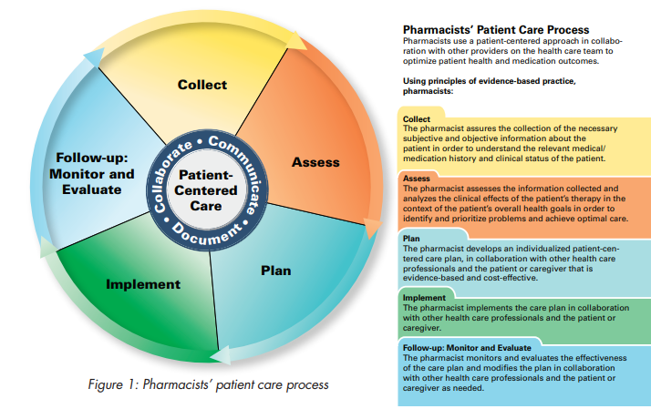

Visit 10_______________________________________________________________Patient-Centered Care
ACTIVITY: For each of the following domains, have preceptor sign if you performed or observed task.

DOMAIN |  | Example Supporting Task |  | Performed | Observed
COLLECT | Collect information to identify a patient’s medication-related problems and health-related needs. | •Collect a medical history from a patient or caregiver.
COLLECT |  | •Collect a medication history from a patient or caregiver.
COLLECT |  | •Discuss a patient’s experience with medication.
COLLECT |  | •Determine a patient’s medication adherence.
COLLECT |  | •Use health records to determine a patient’s health-related needs relevant to setting of care and the purpose of the encounter.
ASSESS | Assess/analyze information to determine the effects of medication therapy, identify medication-related problems, and prioritize health-related needs. | •Assess a patient’s signs and symptoms to determine whether the patient can be treated within the scope of practice or requires a referral.
ASSESS |  | •Measure an adult patient’s vital signs and interpret the results (e.g., body temperature, pulse rate, respiration rate, and blood pressure).
ASSESS |  | •Interpret laboratory test results.
ASSESS |  | •Identify drug interactions.
ASSESS |  | •Perform a comprehensive medication review for a patient.
ASSESS |  | •Assess a patient’s health literacy using a validated screening tool.
ASSESS |  | •Compile a prioritized health-related problem list for a patient.
ASSESS |  | •Evaluate an existing drug therapy regimen.
PLAN | Establish patient-centered goals and create a care plan for a patient in collaboration with the patient, caregiver(s), and other health professionals that is evidence-based and cost-effective. | •Follow an evidence-based disease management protocol.
PLAN |  | •Develop a treatment plan with a patient.
PLAN |  | •Manage drug interactions.
PLAN |  | •Select monitoring parameters to determine the therapeutic and adverse effects related to the treatment plan.
PLAN |  | •Determine the appropriate time interval(s) to collect monitoring data.
PLAN |  | •Create a patient-specific education plan.
IMPLEMENT | Implement a care plan in collaboration with the patient, caregivers, and other health professionals. | •Write a note that documents the findings, recommendations, and plan from a patient encounter.
IMPLEMENT |  | •Educate a patient regarding the appropriate use of a new medication, device to administer a medication, or self-monitoring test.
IMPLEMENT |  | •Educate a patient on the use of medication adherence aids.
IMPLEMENT |  | •Assist a patient with a behavior change (e.g., use shared decision making and motivational strategies).
FOLLOW-UP MONITOR &  EVALUATE | Follow-up and monitor a care plan | •Collect monitoring data at the appropriate time interval(s).
FOLLOW-UP MONITOR &  EVALUATE | Follow-up and monitor a care plan | •Evaluate the selected monitoring parameters to determine the therapeutic and adverse effects related to the treatment plan.
FOLLOW-UP MONITOR &  EVALUATE | Follow-up and monitor a care plan | •Recommend modifications or adjustments to an existing medication therapy regimen based on a patient’s response.
FOLLOW-UP MONITOR &  EVALUATE | Follow-up and monitor a care plan | •Present a patient case to a colleague during a handoff or transition of care.
INTERPROFESSIONAL TEAM | Collaborate as a member of an interprofessional team | • Explain to a patient, caregiver, or professional colleague each team member’s role and responsibilities.  • Communicate a patient’s medication-related problem(s) to another health professional.  • Use setting appropriate communication skills when interacting with others  • Use consensus building strategies to develop a shared plan of action.
POPULATION HEALTH | Identify patients at risk for prevalent diseases in a population | • Perform a screening assessment to identify patients at risk for prevalent diseases in a population (e.g., hypertension, diabetes, depression).
POPULATION HEALTH | Minimize adverse drug events and medication errors. | • Assist in the identification of underlying system-associated causes of errors.  • Report adverse drug events and medication errors to stakeholders.
POPULATION HEALTH | Maximize the appropriate use of medications in a population. | • Perform a medication use evaluation.  • Apply cost-benefit, formulary, and/or epidemiology principles to medication related decisions.
POPULATION HEALTH | Analyze the protective and detrimental  determinants of health to promote social justice. | • Identify systemically at risk populations and provide patient- and population-centered care that is  equitable  • Perform an educational outreach intervention focused on disease prevention and health promotion.
POPULATION HEALTH | Ensure that patients have been  immunized against vaccine preventable diseases. | • Determine whether a patient is eligible for and has received CDC-recommended  immunizations.  • Administer and document CDC-recommended immunizations to an adult patient.  • Perform basic life support.
INFORMATION MASTER | Educate patients and professional  colleagues regarding the appropriate  use of medications. | • Lead a discussion regarding a recently published research manuscript and its  application to patient care.  • Develop and deliver a brief (less than 1 hour) educational program regarding  medication therapy to health professional(s) or lay audience.
INFORMATION MASTER | Use evidence-based information  to advance patient care. | • Retrieve and analyze scientific literature to make a patient-specific recommendation.  • Retrieve and analyze scientific literature to answer a drug information question.
PRACTICE MANGER | Oversee the pharmacy operations  for an assigned work shift. | • Implement pharmacy policies and procedures.  • Supervise and coordinate the activities of pharmacy technicians and other  support staff.  • Assist in training pharmacy technicians and other support staff.  • Assist in the evaluation of pharmacy technicians and other support staff.  • Identify pharmacy service problems and/or medication safety issues.  • Maintain the pharmacy inventory.  • Assist in the management of a pharmacy budget.  • Interpret pharmacy quality and productivity indicators using continuous  improvement quality techniques.  • Assist in the preparation for regulatory visits and inspections.
PRACTICE MANGER | Fulfill a medication order. | • Enter patient-specific information into an electronic health or pharmacy record  system.  • Prepare commonly prescribed medications that require basic sterile  compounding or basic non-sterile compounding prior to patient use.  • Determine if a medication is contraindicated for a patient.  • Identify and manage drug interactions.  • Determine the patient co-pay or price for a prescription.  • Ensure that formulary preferred medications are used when clinically appropriate.  • Obtain authorization for a non-preferred medication when clinically appropriate.  • Assist a patient to acquire medication(s) through support programs.
SELF-DEVELOPER | Create a written plan for continuous  professional development. | • Create and update a curriculum vitae, resume, and/or professional portfolio.  • Perform a self-evaluation to identify professional strengths and weaknesses.
•Adapted from: Pharmacists/ Patient Care Process. May 29, 2014 Joint Commission of Pharmacy Practitioners https://jcpp.net/wp-content/uploads/2016/03/PatientCareProcess-with-supporting-organizations.pdf Accessed November 2023
•Adapted from: Core Entrustable Professional Activities for New Pharmacy Graduates https://www.aacp.org/sites/default/files/2017-10/Appendix1CoreEntrustableProfessionalActivities%20%281%29.pdf Accessed November 2023
Problem Solving
Visit #11

Activity: Identifying Medication-Related Problems
The table below lists seven medication-related or drug therapy problems that patients may experience, as well as possible causes of the problems. Use this table to complete the activity that follows.
Drug Therapy Problem | Cause of the Problem
Unnecessary drug therapy  Wrong drug  Incorrect dose  Adverse drug reaction  Inappropriate compliance  Needs additional therapy | There is no appropriate reason for the patient to be taking the medication  Use of the medication has resulted in the patient taking multiple medications that are the same  The medication is being used to treat an adverse reaction of another drug  The medication can be replaced with non-drug therapy  The medication is being used illegally  The dosage form is not appropriate for the patient  The medication is contraindicated and should not be used for the patient  The medication is not indicated for the condition or problem  More effective medications are available  Dose is too low  Dose is too high  Frequency of use is inappropriate  Duration of use is inappropriate  The medication is administered incorrectly  A drug interaction has changed the way the medication is absorbed or used by the body  The medication is not safe for the patient  The patient has an allergic reaction to the medication  The medication is administered incorrectly  Another drug interacts with the medication  The dose is not changed appropriately  An undesirable effect has resulted from use of the medication  The medication is not available  The patient cannot afford the drug  The patient cannot swallow or administer the drug  Dosing instructions are not understood  Patient does not wish to take drug  The patient has a problem or condition that is not being treated  Adding another drug would make the medication more effective  A medication or vaccine used for prevention is needed
Adapted from: Rovers JP, Currie JD. A Practical Guide to Pharmaceutical Care. 3rd ed. Washington, DC: American Pharmacists Association; 2007.

Ask your preceptor to help you identify three patients who presented to the pharmacy with a medication-related problem that needed to be addressed. Review the profiles of these patients. Complete the table below by stating the problem using the terms provided, giving an explanation of the problem, and prioritizing the problem based on severity and probable outcomes if unresolved.

Problem Solving
Visit #11

Activity: Identifying Medication-Related Problems

Patient | Medication-Related Problem | Explanation of the MRP | MRP Priority  (Low, Medium, High)
1
2
3

Learner
Visit #12
Activity 1: A Trip Down the OTC Aisle: Acetaminophen-Containing Products

- What categories or classes of medications contain acetaminophen?

- Count the number of products that contain acetaminophen. Remember to explore all OTC aisles. How many are there?

- What are the various strengths available?

Calcium and Vitamin D-Containing Products
- Locate, list, and compare products that contain calcium carbonate and calcium citrate. Calculate the daily cost of each product based on the number of tablets needed to get 1200 mg of calcium per day. Note: the amount per dose and amount per tablet may not be the same . . . read the label.
- How much vitamin D does each calcium product contain per tablet?
Brand name | Calcium salt | Amount (mg) per tablet | Cost per day | Vitamin D content

3) Find a multivitamin marketed for women. What is the calcium salt in this product? How much calcium does this product contain? How much vitamin D does this product contain?

Line Extensions and Reformulations
- Locate 2 products that are made by the same manufacturer, have different brand names, but contain the same ingredients. What are the active ingredients that each of these products have in common?
Manufacturer | Brand Name | Active Ingredient(s) | Cost
- Locate 3 products that are made by the same manufacturer, have similar brand names, but contain different active ingredients. What are the active ingredients in each of these products?
Manufacturer | Brand Name | Active Ingredient(s)
Activity 2: OTC Merchandising and Inventory
Learner
Visit #12

Activity 2: A Trip Down the OTC Aisle Weight-Loss Products

- Locate and list all of the vitamin and herbal products marketed for weight loss. Note you may need to explore various sections of the pharmacy to find these products.
- For each product, note the ingredients that would theoretically assist with weight loss and comment as to why each would affect a person’s weight.
- Which products, if any, would you recommend? Why or why not?
- For each of the products listed, what drug or disease interactions would be important to note?

Product Name | Ingredient(s) for Weight Loss and Mechanism of Action | Recommend?  (Y/N) | Why or why not? | Potential interactions

Learner
Visit #12

Activity 3: A Trip Down the OTC Aisle
Note: you will likely need to visit a pharmacy that is within a grocery store to answer the questions in this category.
- Locate and list 4 products that are marketed for patients with diabetes or are likely to be purchased by patients with diabetes.
- Which ones are labeled as “sugar-free”?
- What is the carbohydrate content of each? Sugar alcohols? Fiber? Saturated fat? Unsaturated fat? Sodium?

Product | “Sugar-Free?” (Y/N) | CHO (grams) | Sugar alcohol (grams) | Fiber (grams) | Saturated fat (grams) | Unsaturated fat (grams) | Sodium (mg)

- What are sugar alcohols?

- What are the advantages and disadvantages of using sugar alcohols in food products?

Learner
Visit #12

Activity 4: Inventory of Nonprescription Products

1. How is the inventory for nonprescription products maintained?

2. Does your pharmacy place special orders for nonprescription products for patients?
◻ Yes ◻ No
If so, describe the process for doing so:

3. Which nonprescription products are kept behind the pharmacy counter?

4. What line of products is on the end cap nearest the pharmacy?

5. Which products are on the floor stand nearest the pharmacy?

6. Which products does your preceptor get asked about most often? Where are these placed in the pharmacy or store?

Learner
Visit #13

Activity 1: A Walk Down the OTC Aisle GI-related Products

Activity 1a: Constipation
- Locate 2 FDA-approved agents for constipation relief in children > 2 years of age in your pharmacy site’s OTC aisle.

  - List their name (brand/active ingredient), dosage forms, and 2 counseling points for each of these 2 items for parents using these remedies for their children.

Activity 2a: Diarrhea (LO: 2e)
- Locate 2 remedies for diarrhea for adults in your pharmacy’s OTC aisle.

  - Which of those remedies has potential to be abused?

- Find the active ingredient in regular Pepto-Bismol and Children’s Pepto.
  - What other popular OTC product has the same active ingredient as Children’s Pepto?

- Locate and describe the warning on the package of regular Pepto-Bismol products.

Activity 3a: Nausea/Vomiting
- A patient presents to your pharmacy counter with a box of “Dramamine” and “Dramamine Less-drowsy” saying that he is confused as to why there are two different products available in the OTC aisle with similar sounding names. How do you respond?

- Locate Emetrol in your pharmacy OTC aisle. Based on the active ingredient of this product, what is one chronic disease state that you would be worried about patients using this medication? Give rationale.

Activity 4a: Hemorrhoids (LO: 4d)
- In your pharmacy’s OTC aisle, locate and list different Preparation-H formulations (dosage forms) along with their active ingredients.

Learner
Visit #13

Activity 2: Medication Guides
1. What does REMS stand for?

2. What is a Medication Guide (a.k.a. MedGuide)?

3. Where can you find the Medication Guides in your pharmacy?

4. Give 5 examples of commonly dispensed medications that require Medication Guides:

For more information regarding REMS and available Medication Guides, visit: www.fda.gov/drugs/drugsafety/ucm085729.htm.

Professionalism
Visit #14

Activity 1: Scheduling Shifts

1. Who is responsible for scheduling the pharmacist shifts?

2. Who schedules floater or PRN pharmacists?

3. What happens if a pharmacist who is scheduled to work is unexpectedly unavailable?

4. Who is responsible for scheduling the technicians, student pharmacists, and other personnel?

5. What happens if a technician who is scheduled to work is unexpectedly unavailable?

6. Does the pharmacy have a limit on the number of pharmacist or technician hours that can be scheduled?
◻ Yes ◻ No
If so, explain these limits and how they are determined?

7. Discuss the following with your preceptor:

◻ | Review the current schedule with your preceptor.
◻ | What must be taken into account when creating the schedule?
◻ | Create a draft of the next pharmacy schedule.

Visit #14 Interprofessional Collaboration
ACTIVITY:

1. For Interprofessional Team Member Domain below, discuss with your preceptor ways in which they participate in each supporting task.

2. Have PRECEPTOR sign if you performed or observed the related task during your rotation.

DOMAIN |  | Example Supporting Task | Performed | Observed
INTERPROFESSIONAL TEAM MEMBER DOMAIN | Collaborate as a member of an  interprofessional team. | • Contribute medication-related expertise to the team’s work.
INTERPROFESSIONAL TEAM MEMBER DOMAIN | Collaborate as a member of an  interprofessional team. | • Explain to a patient, caregiver, or professional colleague each team member’s role and responsibilities.
INTERPROFESSIONAL TEAM MEMBER DOMAIN | Collaborate as a member of an  interprofessional team. | • Communicate a patient’s medication-related problem(s) to another health professional.
INTERPROFESSIONAL TEAM MEMBER DOMAIN | Collaborate as a member of an  interprofessional team. | • Use setting appropriate communication skills when interacting with others.
INTERPROFESSIONAL TEAM MEMBER DOMAIN | Collaborate as a member of an  interprofessional team. | • Use consensus-building strategies to develop a shared plan of action.

3. Describe ONE example each in which you learned FROM, WITH, and ABOUT another health professional:

FROM another health care professional example:

WITH another health care professional example:

ABOUT another health care professional example:

Professionalism
Visit #14

Activity 1: Conflict Management
For this activity, you will need to interview both a technician and a pharmacist. Ask each to reflect upon challenging encounters they have had over the past week while at work. These difficult encounters may have been with a patient, another health care provider, or a coworker in which the individual had a different perspective or opinion regarding a situation. Complete the following information:

Technician Response
Details of the Conflict(s) | Persons Involved | Outcome | What Could Have Been Done Differently

Pharmacist Response
Details of the Conflict(s) | Persons Involved | Outcome | What Could Have Been Done Differently

Professionalism
Visit #15

Activity 1: Board Inspections

1. When was the last pharmacy inspection?

2. Who performed the inspection?

3. Was the pharmacy informed of the inspection in advance?

4. Complete the following Self-Inspection Report provided by the Illinois Drug Compliance Unit. Available at: https://idfprapps.illinois.gov/Forms/DPR/F2472.pdf

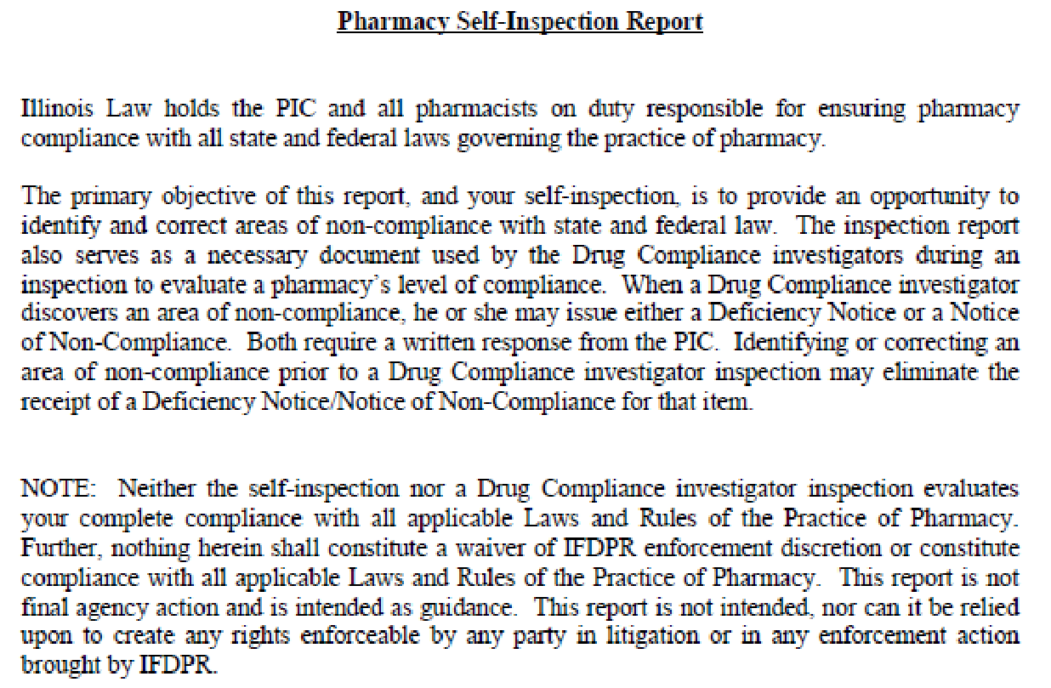

Professionalism
Visit #15

Activity 1: Board Inspections (continued)
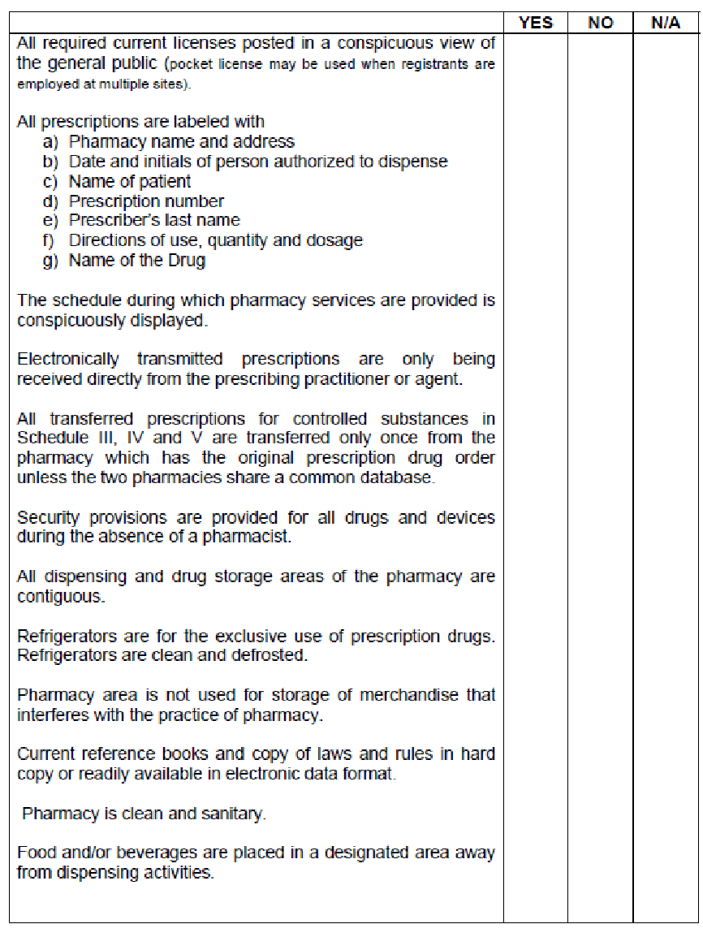
Professionalism
Visit #15

Activity 1: Board Inspections (continued)

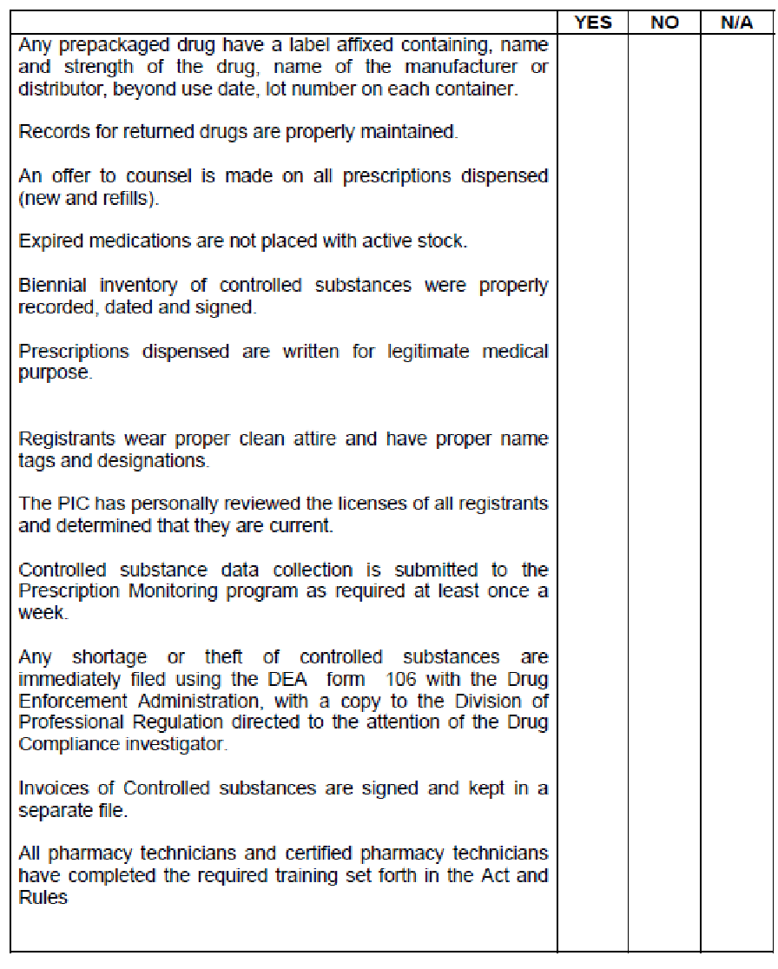

Professionalism & Communication
Visit #15

FINAL EVALUATION: To be completed in CORE-ELMS and discussed

